User Research Strategy Planning Document

1. Brief outline of your Idea - No more than 100 words.

Addition of a feature to a medical app.

Let us consider a hospital named “Croy Hospital” which uses an app called “Croy”. Patients in this hospital that have continuously running medical records are given access to the app with a username and password and can login at any moment in time to access their records, be alerted for upcoming appointments, are able to book or cancel appointments and other regular features as such.

Considering a situation like COVID-19 where patients who have recurring appointments every month or once in 3 months with a doctor should be able to send in a request to their doctor asking for a re-prescription as these appointments may not be held due to the bizarre worldly condition. The doctor can send in a request for delivery of meds to the pharmacy, update the patient’s record, personally message something to the patient (ask them to check their BP thrice in a day and send in records etc. (relating to the image below)) etc.

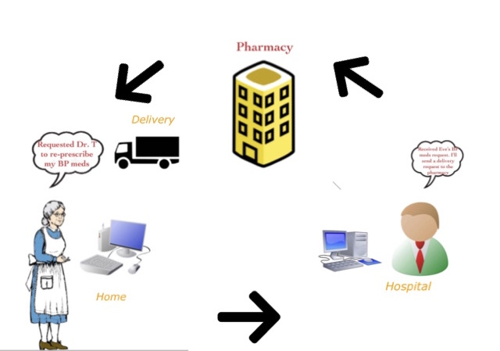

(Received Eve’s BP meds request. I’ll send a delivery request to the pharmacy.)

1. Design thinking approach argument (Problem to Solution) or (Solution to Problem).

This is more of Problem to Solution based situation. During a situation like COVID-19, doctors and other health officials would rather have appointments with patients who need emergency treatment (they will be given priority). Hence it would be nice to have regular patients converse and keep up through certain features on the app.

1. 5 questions for Interview (Qual) Behaviour

* Why or why would you not want to use an application for medical concerns?
* Why do you prefer speaking to your doctor face-to-face?
* In a desperate situation such as a global pandemic, would you consider yourself a person who quickly adapts to changes or would you take a while to adjust?
* Do you have any concerns regarding your medical needs handled in an online manner?
* Tell me about any bad online medical related experience if you’ve had one

1. 10 to 20 questions for Survey in the right order

* How old are you?
* Do you have regular appointments for a certain medical need with a doctor once in a month or once in 3 months? Eg. Blood Pressure check-ups.
* If yes, is it the same doctor you meet every single time? (If not, consider you have a medical need and must meet your doctor every month and answer the rest of the survey).
* Would you feel unsafe to attend these appointments in the middle of a global pandemic? (Considering your registered hospital is taking in patients. Eg: COVID-19 patients).
* If you were provided with sanitizer, hand gloves and masks on entry to the hospital, would you still feel unsafe?
* Would you consider using an application that can manage all your appointments and medical records?
* Would you rather use the same application to keep in touch with your doctor or would you prefer walk-in’s?
* Do you fear a misunderstanding in communication with your doctor related to any of your medical needs if it were all held online?
* Do you fear delay in delivery of your meds due to technical issues?
* Would you prefer picking up your own meds from the pharmacy during the pandemic or have it delivered?
* How comfortable would you feel in using and conversing with your doctor over an application?